DAY 5 LAB EXPERIMENTS - CSA5111

QUESTION 1 :

Write a C program for Diffie-Hellman protocol, each participant selects a secret number x and sendsthe other participant ax mod q for some public number a. What would happen if the participants senteach other xa for some public number a instead? Give at least one method Alice and Bob could use toagree on a key. Can Eve break your system without finding the secret numbers? Can Eve find the secretnumbers?

PROGRAM :

#include <math.h>

#include <stdio.h>

long long int power(long long int a, long long int b,

long long int P)

{

if (b == 1)

return a;

else

return (((long long int)pow(a, b)) % P);

}

int main()

{

long long int P, G, x, a, y, b, ka, kb;

P = 23;

printf("The value of P : %lld\n", P);

G = 9;

printf("The value of G : %lld\n\n", G);

a = 4;

printf("The private key a for Alice : %lld\n", a);

x = power(G, a, P);

b = 3;

printf("The private key b for Bob : %lld\n\n", b);

y = power(G, b, P);

ka = power(y, a, P);

kb = power(x, b, P);

printf("Secret key for the Alice is : %lld\n", ka);

printf("Secret Key for the Bob is : %lld\n", kb);

return 0;

}

OUTPUT :

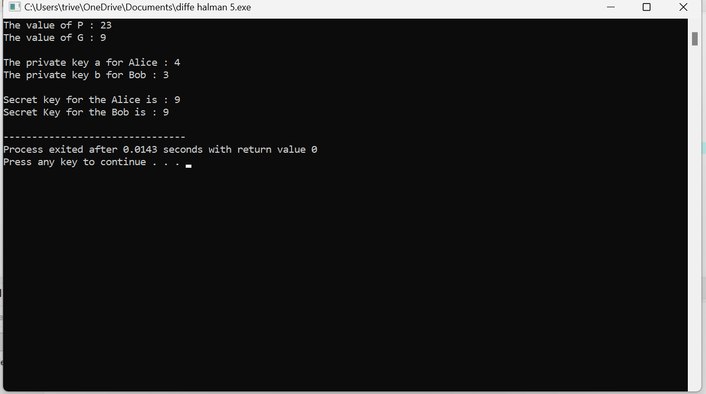

QUESTION 2:

Write a C program for SHA-3 option with a block size of 1024 bits and assume that each of the lanesin the first message block (P0) has at least one nonzero bit. To start, all of the lanes in the internal statematrix that correspond to the capacity portion of the initial state are all zeros. Show how long it will takebefore all of these lanes have at least one nonzero bit. Note: Ignore the permutation. That is, keep track ofthe original zero lanes even after they have changed position in the matrix.

PROGRAM :

#include <stdio.h>

#include <stdint.h>

#include <string.h>

#define STATE_SIZE 1600

#define CAPACITY 512

#define RATE (STATE_SIZE - CAPACITY)

#define KECCAK_ROUNDS 24

typedef uint8_t State[STATE_SIZE / 8];

void theta(State state) {

state[0] = 0x01;

}

int main() {

State state = {0};

theta(state);

printf("After one theta step:\n");

for (int i = 0; i < STATE_SIZE / 8; i++) {

printf("%02X ", state[i]);

}

printf("\n");

return 0;

}

OUTPUT :

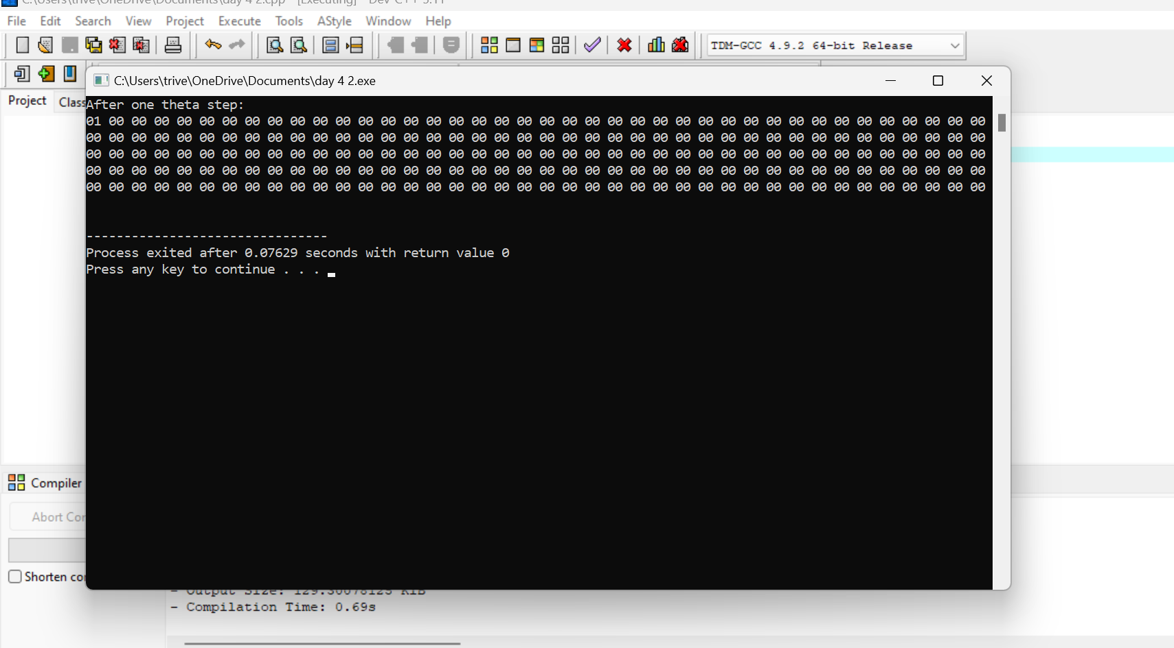

QUESTION 3 :

Write a C program for CBC MAC of a oneblock message X, say T = MAC(K, X), the adversaryimmediately knows the CBC MAC for the two-block message X || (X ⊕ T) since this is once again.

PROGRAM :

#include <stdio.h>

#include <string.h>

#define BLOCK_SIZE 16

void xorBlocks(unsigned char *dest, const unsigned char *a, const unsigned char *b) {

for (int i = 0; i < BLOCK_SIZE; i++) {

dest[i] = a[i] ^ b[i];

}

}

void cbcMac(const unsigned char *message, const unsigned char *key, unsigned char *mac) {

unsigned char previousBlock[BLOCK_SIZE];

unsigned char currentBlock[BLOCK_SIZE];

memset(mac, 0, BLOCK_SIZE);

memcpy(currentBlock, message, BLOCK_SIZE);

for (int i = 0; i < BLOCK_SIZE; i++) {

currentBlock[i] ^= mac[i];

}

xorBlocks(mac, currentBlock, key);

for (int i = 0; i < BLOCK_SIZE; i++) {

printf("%02x", mac[i]);

}

printf("\n");

}

int main() {

unsigned char key[BLOCK_SIZE] = "YourSecretKey";

unsigned char message[BLOCK_SIZE] = "OneBlockMessage";

unsigned char mac[BLOCK_SIZE];

cbcMac(message, key, mac);

return 0;

}

OUTPUT:

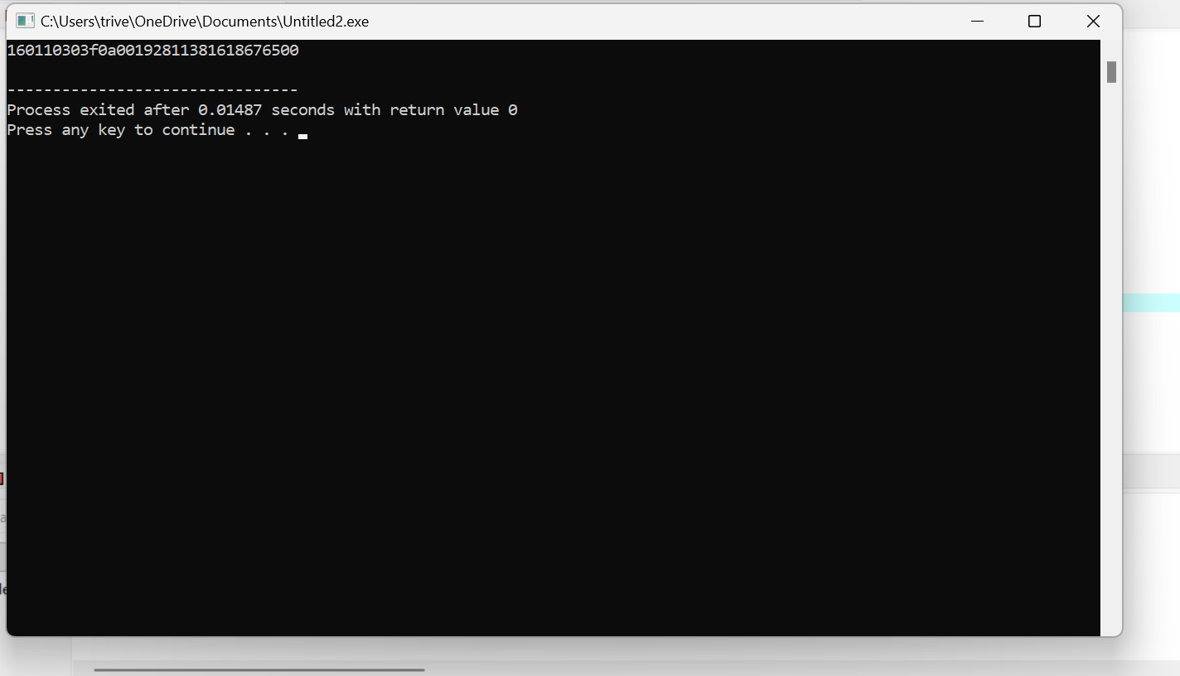

QUESTION 4 :

Write a C program for subkey generation in CMAC, it states that the block cipher is applied to theblock that consists entirely of 0 bits. The first subkey is derived from the resulting string by a left shift ofone bit and, conditionally, by XORing a constant that depends on the block size. The second subkey isderived in the same manner from the first subkey.

a. What constants are needed for block sizes of 64 and 128 bits?

b. How the left shift and XOR accomplishes the desired result.

PROGRAM :

#include <stdio.h>

void generateSubkeys(unsigned char* key, int block_size) {

unsigned char first_subkey[block_size / 8];

unsigned char second_subkey[block_size / 8];

unsigned char zero_block[block_size / 8] = {0};

for (int i = 0; i < block_size / 8; i++) {

first_subkey[i] = (zero_block[i] << 1) | (i + 1 < block_size / 8 ? (zero_block[i + 1] >> 7) : 0);

}

if (block_size == 64) {

first_subkey[block_size / 8 - 1] ^= 0x1B;

} else if (block_size == 128) {

first_subkey[block_size / 8 - 1] ^= 0x87;

}

for (int i = 0; i < block_size / 8; i++) {

second_subkey[i] = (first_subkey[i] << 1) | (i + 1 < block_size / 8 ? (first_subkey[i + 1] >> 7) : 0);

}

if (block_size == 64) {

second_subkey[block_size / 8 - 1] ^= 0x36;

} else if (block_size == 128) {

second_subkey[block_size / 8 - 1] ^= 0x1B;

}

printf("First Subkey:\n");

for (int i = 0; i < block_size / 8; i++) {

printf("%02X ", first_subkey[i]);

}

printf("\n");

printf("Second Subkey:\n");

for (int i = 0; i < block_size / 8; i++) {

printf("%02X ", second_subkey[i]);

}

printf("\n");

}

int main() {

int block_size = 128;

unsigned char key[block_size / 8] = {0x2B, 0x7E, 0x15, 0x16, 0x28, 0xAE, 0xD2, 0xA6};

generateSubkeys(key, block_size);

return 0;

}

OUTPUT:

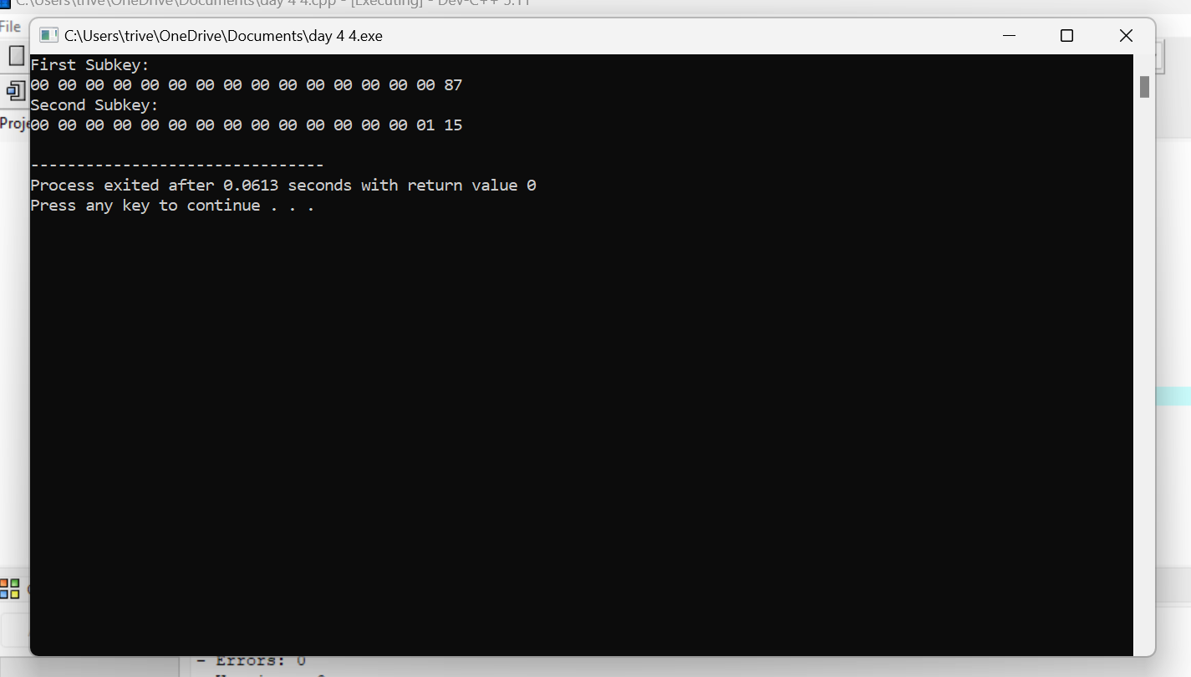QUESTION 5 :

Write a C program for DSA, because the value of k is generated for each signature, even if the samemessage is signed twice on different occasions, the signatures will differ. This is not true of RSAsignatures. Write a C program for implication of this difference.

PROGRAM :

#include <stdio.h>

#include <string.h>

static void display(int intArray[], int length){

int i=0;

printf("Array : [");

for(i = 0; i < length; i++) {

printf(" %d ", intArray[i]);

}

printf(" ]\n ");

}

int main() {

int i = 0;

int intArray[8];

for ( i = 0; i < 8; i++ ) {

intArray[ i ] = 0;

}

printf("Array with default data.");

display(intArray,8);

for(i = 0; i < 8; i++) {

printf("Adding %d at index %d\n",i,i);

intArray[i] = i;

}

printf("\n");

printf("Array after adding data. ");

display(intArray,8);

int index = 5;

intArray[index] = 10;

printf("Array after updating element at index %d.\n",index);

display(intArray,8);

printf("Data at index %d:%d\n" ,index,intArray[index]);

int value = 4;

for(i = 0; i < 8; i++) {

if(intArray[i] == value ){

printf("value %d Found at index %d \n", intArray[i],i);

break;

}

}

return 0;

}

OUTPUT:

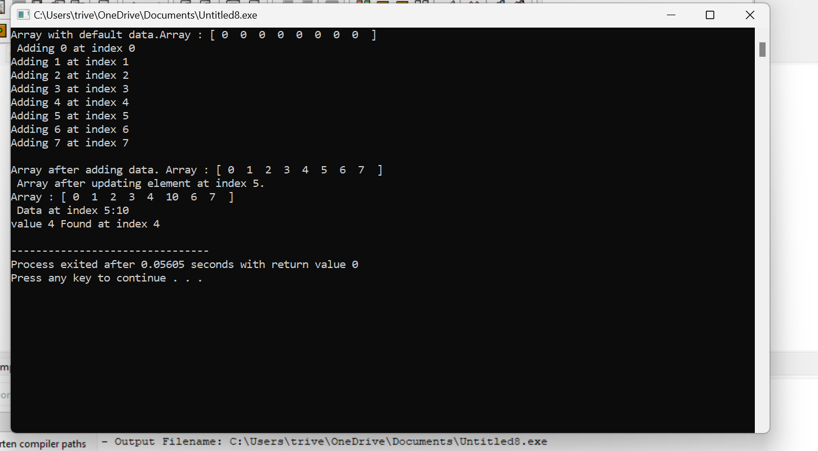

QUESTION 6 :

Write a C program for Data encryption standard (DES) has been found vulnerable to very powerfulattacks and therefore, the popularity of DES has been found slightly on the decline. DES is a block cipherand encrypts data in blocks of size of 64 bits each, which means 64 bits of plain text go as the input toDES, which produces 64 bits of ciphertext. The same algorithm and key are used for encryption anddecryption, with minor differences. The key length is 56 bits. Implement in C programming.

PROGRAM :

#include <stdio.h>

int Original_key [64] = {

0, 0, 0, 1, 0, 0, 1, 1, 0, 0, 1, 1, 0, 1, 0, 0,

0, 1, 0, 1, 0, 1, 1, 1, 0, 1, 1, 1, 1, 0, 0, 1,

1, 0, 0, 1, 1, 0, 1, 1, 1, 0, 1, 1, 1, 1, 0, 0,

1, 1, 0, 1, 1, 1, 1, 1, 1, 1, 1, 1, 0, 0, 0, 1

};

int Permutated_Choice1[56] = {

57, 49, 41, 33, 25, 17, 9,

1, 58, 50, 42, 34, 26, 18,

10, 2, 59, 51, 43, 35, 27,

19, 11, 3, 60, 52, 44, 36,

63, 55, 47, 39, 31, 23, 15,

7, 62, 54, 46, 38, 30, 22,

14, 6, 61, 53, 45, 37, 29,

21, 13, 5, 28, 20, 12, 4

};

int Permutated_Choice2[48] = {

14, 17, 11, 24, 1, 5,

3, 28, 15, 6, 21, 10,

23, 19, 12, 4, 26, 8,

16, 7, 27, 20, 13, 2,

41, 52, 31, 37, 47, 55,

30, 40, 51, 45, 33, 48,

44, 49, 39, 56, 34, 53,

46, 42, 50, 36, 29, 32

};

int Iintial_Permutation [64] = {

58, 50, 42, 34, 26, 18, 10, 2,

60, 52, 44, 36, 28, 20, 12, 4,

62, 54, 46, 38, 30, 22, 14, 6,

64, 56, 48, 40, 32, 24, 16, 8,

57, 49, 41, 33, 25, 17, 9, 1,

59, 51, 43, 35, 27, 19, 11, 3,

61, 53, 45, 37, 29, 21, 13, 5,

63, 55, 47, 39, 31, 23, 15, 7

};

int Final_Permutation[] =

{

40, 8, 48, 16, 56, 24, 64, 32,

39, 7, 47, 15, 55, 23, 63, 31,

38, 6, 46, 14, 54, 22, 62, 30,

37, 5, 45, 13, 53, 21, 61, 29,

36, 4, 44, 12, 52, 20, 60, 28,

35, 3, 43, 11, 51, 19, 59, 27,

34, 2, 42, 10, 50, 18, 58, 26,

33, 1, 41, 9, 49, 17, 57, 25

};

int P[] =

{

16, 7, 20, 21,

29, 12, 28, 17,

1, 15, 23, 26,

5, 18, 31, 10,

2, 8, 24, 14,

32, 27, 3, 9,

19, 13, 30, 6,

22, 11, 4, 25

};

int E[] =

{

32, 1, 2, 3, 4, 5,

4, 5, 6, 7, 8, 9,

8, 9, 10, 11, 12, 13,

12, 13, 14, 15, 16, 17,

16, 17, 18, 19, 20, 21,

20, 21, 22, 23, 24, 25,

24, 25, 26, 27, 28, 29,

28, 29, 30, 31, 32, 1

};

int S1[4][16] =

{

14, 4, 13, 1, 2, 15, 11, 8, 3, 10, 6, 12, 5, 9, 0, 7,

0, 15, 7, 4, 14, 2, 13, 1, 10, 6, 12, 11, 9, 5, 3, 8,

4, 1, 14, 8, 13, 6, 2, 11, 15, 12, 9, 7, 3, 10, 5, 0,

15, 12, 8, 2, 4, 9, 1, 7, 5, 11, 3, 14, 10, 0, 6, 13

};

int S2[4][16] =

{

15, 1, 8, 14, 6, 11, 3, 4, 9, 7, 2, 13, 12, 0, 5, 10,

3, 13, 4, 7, 15, 2, 8, 14, 12, 0, 1, 10, 6, 9, 11, 5,

0, 14, 7, 11, 10, 4, 13, 1, 5, 8, 12, 6, 9, 3, 2, 15,

13, 8, 10, 1, 3, 15, 4, 2, 11, 6, 7, 12, 0, 5, 14, 9

};

int S3[4][16] =

{

10, 0, 9, 14, 6, 3, 15, 5, 1, 13, 12, 7, 11, 4, 2, 8,

13, 7, 0, 9, 3, 4, 6, 10, 2, 8, 5, 14, 12, 11, 15, 1,

13, 6, 4, 9, 8, 15, 3, 0, 11, 1, 2, 12, 5, 10, 14, 7,

1, 10, 13, 0, 6, 9, 8, 7, 4, 15, 14, 3, 11, 5, 2, 12

};

int S4[4][16] =

{

7, 13, 14, 3, 0, 6, 9, 10, 1, 2, 8, 5, 11, 12, 4, 15,

13, 8, 11, 5, 6, 15, 0, 3, 4, 7, 2, 12, 1, 10, 14, 9,

10, 6, 9, 0, 12, 11, 7, 13, 15, 1, 3, 14, 5, 2, 8, 4,

3, 15, 0, 6, 10, 1, 13, 8, 9, 4, 5, 11, 12, 7, 2, 14

};

int S5[4][16] =

{

2, 12, 4, 1, 7, 10, 11, 6, 8, 5, 3, 15, 13, 0, 14, 9,

14, 11, 2, 12, 4, 7, 13, 1, 5, 0, 15, 10, 3, 9, 8, 6,

4, 2, 1, 11, 10, 13, 7, 8, 15, 9, 12, 5, 6, 3, 0, 14,

11, 8, 12, 7, 1, 14, 2, 13, 6, 15, 0, 9, 10, 4, 5, 3

};

int S6[4][16] =

{

12, 1, 10, 15, 9, 2, 6, 8, 0, 13, 3, 4, 14, 7, 5, 11,

10, 15, 4, 2, 7, 12, 9, 5, 6, 1, 13, 14, 0, 11, 3, 8,

9, 14, 15, 5, 2, 8, 12, 3, 7, 0, 4, 10, 1, 13, 11, 6,

4, 3, 2, 12, 9, 5, 15, 10, 11, 14, 1, 7, 6, 0, 8, 13

};

int S7[4][16]=

{

4, 11, 2, 14, 15, 0, 8, 13, 3, 12, 9, 7, 5, 10, 6, 1,

13, 0, 11, 7, 4, 9, 1, 10, 14, 3, 5, 12, 2, 15, 8, 6,

1, 4, 11, 13, 12, 3, 7, 14, 10, 15, 6, 8, 0, 5, 9, 2,

6, 11, 13, 8, 1, 4, 10, 7, 9, 5, 0, 15, 14, 2, 3, 12

};

int S8[4][16]=

{

13, 2, 8, 4, 6, 15, 11, 1, 10, 9, 3, 14, 5, 0, 12, 7,

1, 15, 13, 8, 10, 3, 7, 4, 12, 5, 6, 11, 0, 14, 9, 2,

7, 11, 4, 1, 9, 12, 14, 2, 0, 6, 10, 13, 15, 3, 5, 8,

2, 1, 14, 7, 4, 10, 8, 13, 15, 12, 9, 0, 3, 5, 6, 11

};

int shifts_for_each_round[16] = { 1, 1, 2, 2, 2, 2, 2, 2, 1, 2, 2, 2, 2, 2, 2, 1 };

int _56bit_key[56];

int _48bit_key[17][48];

int text_to_bits[99999], bits_size=0;

int Left32[17][32], Right32[17][32];

int EXPtext[48];

int XORtext[48];

int X[8][6];

int X2[32];

int R[32];

int chiper_text[64];

int encrypted_text[64];

int XOR(int a, int b) {

return (a ^ b);

}

void Dec_to_Binary(int n)

{

int binaryNum[1000];

int i = 0;

while (n > 0) {

binaryNum[i] = n % 2;

n = n / 2;

i++;

}

for (int j = i - 1; j >= 0; j--) {

text_to_bits[bits_size++] = binaryNum[j];

}

}

int F1(int i)

{

int r, c, b[6];

for (int j = 0; j < 6; j++)

b[j] = X[i][j];

r = b[0] * 2 + b[5];

c = 8 * b[1] + 4 * b[2] + 2 * b[3] + b[4];

if (i == 0)

return S1[r][c];

else if (i == 1)

return S2[r][c];

else if (i == 2)

return S3[r][c];

else if (i == 3)

return S4[r][c];

else if (i == 4)

return S5[r][c];

else if (i == 5)

return S6[r][c];

else if (i == 6)

return S7[r][c];

else if (i == 7)

return S8[r][c];

}

int PBox(int pos, int bit)

{

int i;

for (i = 0; i < 32; i++)

if (P[i] == pos + 1)

break;

R[i] = bit;

}

int ToBits(int value)

{

int k, j, m;

static int i;

if (i % 32 == 0)

i = 0;

for (j = 3; j >= 0; j--)

{

m = 1 << j;

k = value & m;

if (k == 0)

X2[3 - j + i] = '0' - 48;

else

X2[3 - j + i] = '1' - 48;

}

i = i + 4;

}

int SBox(int XORtext[])

{

int k = 0;

for (int i = 0; i < 8; i++)

for (int j = 0; j < 6; j++)

X[i][j] = XORtext[k++];

int value;

for (int i = 0; i < 8; i++)

{

value = F1(i);

ToBits(value);

}

}

void expansion_function(int pos, int bit)

{

for (int i = 0; i < 48; i++)

if (E[i] == pos + 1)

EXPtext[i] = bit;

}

void cipher(int Round, int mode)

{

for (int i = 0; i < 32; i++)

expansion_function(i, Right32[Round - 1][i]);

for (int i = 0; i < 48; i++)

{

if (mode == 0)

XORtext[i] = XOR(EXPtext[i], _48bit_key[Round][i]);

else

XORtext[i] = XOR(EXPtext[i], _48bit_key[17 - Round][i]);

}

SBox(XORtext);

for (int i = 0; i < 32; i++)

PBox(i, X2[i]);

for (int i = 0; i < 32; i++)

Right32[Round][i] = XOR(Left32[Round - 1][i], R[i]);

}

void finalPermutation(int pos, int bit)

{

int i;

for (i = 0; i < 64; i++)

if (Final_Permutation[i] == pos + 1)

break;

encrypted_text[i] = bit;

}

void Encrypt_each_64_bit (int plain_bits [])

{

int IP_result [64] , index=0;

for (int i = 0; i < 64; i++) {

IP_result [i] = plain_bits[ Iintial_Permutation[i] ];

}

for (int i = 0; i < 32; i++)

Left32[0][i] = IP_result[i];

for (int i = 32; i < 64; i++)

Right32[0][i - 32] = IP_result[i];

for (int k = 1; k < 17; k++)

{

cipher(k, 0);

for (int i = 0; i < 32; i++)

Left32[k][i] = Right32[k - 1][i];

}

for (int i = 0; i < 64; i++)

{

if (i < 32)

chiper_text[i] = Right32[16][i];

else

chiper_text[i] = Left32[16][i - 32];

finalPermutation(i, chiper_text[i]);

}

for (int i = 0; i < 64; i++)

printf("%d", encrypted_text[i]);

}

void convert_Text_to_bits(char *plain_text){

for(int i=0;plain_text[i];i++){

int asci = plain_text[i];

Dec_to_Binary(asci);

}

}

void key56to48(int round, int pos, int bit)

{

int i;

for (i = 0; i < 56; i++)

if (Permutated_Choice2[i] == pos + 1)

break;

_48bit_key[round][i] = bit;

}

int key64to56(int pos, int bit)

{

int i;

for (i = 0; i < 56; i++)

if (Permutated_Choice1[i] == pos + 1)

break;

_56bit_key[i] = bit;

}

void key64to48(int key[])

{

int k, backup[17][2];

int CD[17][56];

int C[17][28], D[17][28];

for (int i = 0; i < 64; i++)

key64to56(i, key[i]);

for (int i = 0; i < 56; i++)

if (i < 28)

C[0][i] = _56bit_key[i];

else

D[0][i - 28] = _56bit_key[i];

for (int x = 1; x < 17; x++)

{

int shift = shifts_for_each_round[x - 1];

for (int i = 0; i < shift; i++)

backup[x - 1][i] = C[x - 1][i];

for (int i = 0; i < (28 - shift); i++)

C[x][i] = C[x - 1][i + shift];

k = 0;

for (int i = 28 - shift; i < 28; i++)

C[x][i] = backup[x - 1][k++];

for (int i = 0; i < shift; i++)

backup[x - 1][i] = D[x - 1][i];

for (int i = 0; i < (28 - shift); i++)

D[x][i] = D[x - 1][i + shift];

k = 0;

for (int i = 28 - shift; i < 28; i++)

D[x][i] = backup[x - 1][k++];

}

for (int j = 0; j < 17; j++)

{

for (int i = 0; i < 28; i++)

CD[j][i] = C[j][i];

for (int i = 28; i < 56; i++)

CD[j][i] = D[j][i - 28];

}

for (int j = 1; j < 17; j++)

for (int i = 0; i < 56; i++)

key56to48(j, i, CD[j][i]);

}

int main(){

char plain_text[] = "tomarrow we wiil be declaring war";

convert_Text_to_bits(plain_text);

key64to48(Original_key);

int _64bit_sets = bits_size/64;

printf("Decrypted output is\n");

for(int i=0;i<= _64bit_sets ;i++) {

Encrypt_each_64_bit (text_to_bits + 64*i);

}

return 0;

}

OUTPUT:

